**CLIENT SIDE SCRIPTING (CSS)**

**MICRO- PROJECT**

I being a students of Third Year 5th Sem IT would like to present my

MICRO-PROJECT on Client Side Scripting and the topic is

“Portfolio Of Mobile Website using Java Script”. My Details Are :

**MANIYAR YUNUS IRFAN 17811**

I would like to thank our respected **Ms. Munira Ansari** for

her guidance and support for making my project successful.

**TABLE OF CONTENT:**

|  |  |
| --- | --- |
| **Topic** | **Page No** |
| **Introduction** | 3 |
| **Source Code** | 4 |
| **Output** | 26 |
| **Actual Resources used** | 37 |

**INTRODUCTION**

Web developers often work for clients who are trying to get their product or service onto the web. The work is typically very project focused and involves collaborating with a team that helps to coordinate the client’s needs into the end product. The client could be a tech company, an organization, or a government. The work could involve front-end, back-end, or full-stack web development.

Web development could be a good profession for you if you like solving logical problems, building useful things, and experimenting with new technologies. Web developers are in high demand, generally have a good work/life balance, and command comfortable salaries. Google your specific location to get a better sense of your local web development job opportunities

The client-side environment used to run scripts is usually a browser. The processing takes place on the end users computer. The source code is transferred from the web server to the users computer over the internet and run directly in the browser.[2]

The scripting language needs to be enabled on the client computer. Sometimes if a user is conscious of security risks they may switch the scripting facility off. When this is the case a message usually pops up to alert the user when script is attempting to run.

**SOURCE CODE**

**HOME.HTML**

<!DOCTYPE html>

<html>

<head>

<title>

Main

</title>

<link rel="stylesheet" type="text/css" href="style.css">

<script>

var arr= ["note7banner.jpg","mia3banner.jpg","mi9Tbanner.jpg","mimixbanner.jpg"];

var c=0;

function f1(){

document.img.src = arr[c]; c++;

if(c==arr.length){

c=0;

}

setTimeout(f1,3000); }

window.onload=f1;

</script>

</head>

<body>

<ul class="nav">

<li><a href="Sign.html">Sign In </a></li>

<li><a href="Mi.html"> MI Phones </a></li>

<li><a href="Redmi.html">Redmi Phones</a></li>

<li><a href="About.html">About</a></li>

<li><a href="Home.html">Home</a></li>

<li class="xiaomi">

<img src="xiaomi.png" height=50px width=50px style="margin-bottom: 55px;margin-top: -6px">

<div style="margin-top:-90px; margin-left:80px"> XIAOMI </div> </li>

</ul>

<img name="img" width="100%" height="90%">

</body>

</html>

**ABOUT.HTML**

<!DOCTYPE html>

<html>

<head>

<title>About Us</title>

<link rel="stylesheet" type="text/css" href="style.css">

</head>

<body>

<ul class="nav">

<li><a href="Sign.html">Sign In </a></li>

<li><a href="Mi.html"> MI Phones </a></li>

<li><a href="Redmi.html"> Redmi Phones</a></li>

<li><a href="About.html">About</a></li>

<li><a href="Home.html">Home</a></li>

<li class="xiaomi">

<img src="xiaomi.png" height=50px width=50px style="margin-bottom: 55px;margin-top: -6px">

<div style="margin-top:-90px; margin-left:80px"> XIAOMI </div></li>

</ul>

<center>

<div class="i" align=center><img src="xiaomi.png" width="20%" height="20%">

<div class="txt"align=center >

Xiaomi was founded in 2010 by serial entrepreneur Lei Jun based on the vision “innovation for everyone”.

We believe that high-quality products built with cutting-edge technology should be made accessible to everyone.

We create remarkable hardware, software, and Internet services for and with the help of our Mi fans. We incorporate

their feedback into our product range, which currently includes Mi and Redmi smartphones, Mi TVs and set-top boxes,

Mi routers, and Mi Ecosystem products including smart home products, wearables and other accessories.

With presence in over 30 countries and regions, Xiaomi is expanding its footprint across the world to

become a global brand. <hr>

Xiaomi is focused on being the most user-centric mobile internet company, and we aim

to constantly exceed expectations through innovations in software, hardware and services.

Many of our employees were initially fans of Mi products, before they decided to join us. Our team is

not only passionate about technology, but also relentlessly pursues perfection to break tradition and

push boundaries, all just to ensure that our products remain unique and offer an unparalleled user

experience. Xiaomi is headquartered in Beijing, China and has offices

in Asia-Pacific, India, and Europe.

</div>

</center>

</body>

</html>

**REDMI.HTML**

<!DOCTYPE html>

<html>

<head>

<title> Redmi Phones </title>

<link rel="stylesheet" type="text/css" href="style.css">

</head>

<frameset cols="15%,*" frameborder="1">

<frame src="sam.html" name="frame1">

<frame src="empty.html" name="frame2">

</frameset>

</html>

**SAM.HTML**

<html>

<head>

<style>

input[type=button]{

border-radius: 10px; }

</style>

<script>

function f1() {

parent.location.href="Home.html";

}

function f2() {

parent.location.href="about.html";

}

function f3() {

parent.location.href="Redmi.html";

}

function f4() {

parent.location.href="Mi.html";

}

function f5() {

parent.location.href="Sign.html";

}

</script>

</head>

<body style=background-image:url("back.jpg")>

<div id="2" style="margin-top: 70px; margin-left: 10px">

<a href="redmi1.html" target="frame2"> REDMI NOTE 7 </a> <br> <br>

<a href="redmi2.html" target="frame2"> REDMI NOTE 6 PRO </a> <br> <br>

<a href="redmi3.html" target="frame2"> REDMI Y3</a> <br> <br>

<a href="redmi4.html" target="frame2"> REDMI NOTE 5 </a> <br> <br>

<a href="redmi5.html" target="frame2"> REDMI GO </a> <br> <br> <br> <br> <br>

<form>

<input type="button" value="HOME" onclick="f1()"> &nbsp &nbsp &nbsp <input type="button" value="ABOUT" onclick="f2()"> <br> <br>

<input type="button" value="REDMI" onclick="f3()"> &nbsp &nbsp &nbsp <input type="button" value="MI" onclick="f4()"> <br> <br>

<input type="button" value="SIGN IN" onclick="f5()">

</form>

</body>

</html>

**REDMI1.HTML**

<!DOCTYPE html>

<html>

<head>

<title> Redmi Phones </title>

<link rel="stylesheet" type="text/css" href="style.css">

</head>

<body style=background-image:url("back.jpg")>

<center>

<div class="card"><img src="redminote7.jpg" width="100%" style="border-radius: 7%">

<h3 align="center"> REDMI NOTE 7</h3><br>

Resolution - 1080 x 2340 pixels, 19.5:9 ratio

OS - Android 9.0 (Pie) MIUI 10

Chipset Qualcomm SDM675 Snapdragon 675 (11 nm)

Internal - 64GB 4GB RAM, 64GB 6GB RAM, 128GB 6GB RAM <br>

MAIN CAMERA - Dual 48 MP, f/1.8, (wide), 1/2",

5 MP, f/2.4, depth sensor

Features - Dual-LED flash, HDR, panorama

SELFIE CAMERA - Single 13 MP <br>

BATTERY - Non-removable Li-Po 4000 mAh battery

Charging - Fast battery charging 18W (Quick Charge 4)

Colors - Nebula Red, Neptune Blue, Space Black, Astro White

</div>

</center>

</body>

</html>

**REDMI2.HTML**

<!DOCTYPE html>

<html>

<head>

<title> Redmi Phones </title>

<link rel="stylesheet" type="text/css" href="style.css">

</head>

<body style=background-image:url("back.jpg")>

<center>

<div class="card"><img src="mi6pro.jpg" width="100%" style="border-radius: 7%">

<h3 align="center"> REDMI NOTE 6 PRO </h3><br>

Operating System. Android v8.1 (Oreo) Upgradable to v9.0 (Pie)<br>

5.84 inches (14.83 cm) bezel-less display with notch.<br>

Qualcomm Snapdragon 625 MSM8953 Tru-Octa Core Processor. 3 GB RAM<br>

12 + 5 MP Dual Rear Cameras. 5 MP Front Camera.

</div>

</center>

</body>

</html>

**REDMI3.HTML**

<!DOCTYPE html>

<html>

<head>

<title> Redmi Phones </title>

<link rel="stylesheet" type="text/css" href="style.css">

</head>

<body style=background-image:url("back.jpg")>

<center>

<div class="card"><img src="miy3.jpg" width="100%" style="border-radius: 7%">

<h3 align="center"> REDMI Y3 </h3><br>

Display - 6.26-inch (720x1520)

Processor - Qualcomm Snapdragon 632<br>

Front Camera - 32MP , Rear Camera - 12MP + 2MP

RAM - 3GB , Storage - 32GB <br>

Battery Capacity - 4000mAh<br>

OS - Android 9 Pie

</div>

</center>

</body>

</html>

**REDMI4.HTML**

<!DOCTYPE html>

<html>

<head>

<title> Redmi Phones </title>

<link rel="stylesheet" type="text/css" href="style.css">

</head>

<body style=background-image:url("back.jpg")> <center>

<div class="card"><img src="redminote5pro.jpg" width="100%" style="border-radius: 5%">

<h3 align="center"> REDMI NOTE 5 PRO </h3><br>

Android v7.1.2 (Nougat), upgradable to v9.0 (Pie)

Snapdragon 636 4 GB RAM

Display5.99 inches (15.21 cm)1080x2160 px, 403 PPIIPS LCD

Camera - 12 MP + 5 MP Dual Primary Camera - Dual-color LED Flash 20 MP Front Camera

Battery4000 mAhQuick Charging 2.0

</div> </center>

</body>

</html>

**REDMI5.HTML**

<!DOCTYPE html>

<html>

<head>

<title> Redmi Phones </title>

<link rel="stylesheet" type="text/css" href="style.css">

</head>

<body style=background-image:url("back.jpg")>

<center>

<div class="card"><img src="migo.jpg" width="100%" style="border-radius: 7%">

<h3 align="center"> REDMI GO </h3><br>

Android v8.1 (Oreo)

3000 mAh battery <br>

5.0 inches (12.7 cm) display

Qualcomm Snapdragon 425 MSM8917 <br> Quad core Processor

1 GB RAM

8 GB internal storage

8 MP Rear Camera <br>

5 MP Front Camera

</div>

</center>

</body>

</html>

**EMPTY.HMTL**

<html>

<head>

<link rel="stylesheet" type="text/css" href="style.css">

</head>

<body style=background-image:url("back.jpg")>

<br>

<h2 style="color: white"> <center> REDMI PHONES </center> </h2>

</body>

</html>

**MI.HTML**

<!DOCTYPE html>

<html>

<head>

<title>MI Phones</title>

<link rel="stylesheet" type="text/css" href="style.css">

</head>

<frameset cols="15%,*" frameborder="1">

<frame src="sam1.html" name="f1">

<frame src="empty1.html" name="f2">

</frameset>

</html>

**MI1.HTML**

<!DOCTYPE html>

<html>

<head>

<title> MI Phones </title>

<link rel="stylesheet" type="text/css" href="style.css">

</head>

<body>

<center>

<div class="card"><img src="mimix2.jpg" width="100%" style="border-radius: 6%">

<h3 align="center"> MI MIX 2 </h3><br>

SIM - Dual SIM (Nano-SIM, dual stand-by)

DISPLAY - IPS LCD capacitive touchscreen, 16M colors

OS - Android 7.1 (Nougat), 8.0 (Oreo), MIUI 10

Qualcomm Snapdragon 835 (10 nm)

Internal - 64GB 6GB RAM, 128GB 6GB RAM, 128GB 8GB RAM,

MAIN CAMERA - Single 12 MP, f/2.0, 1/2.9", 1.25,

SELFIE CAMERA - Single 5 MP, f/2.0

</div>

</center>

</body>

</html>

**MI2.HTML**

<!DOCTYPE html>

<html>

<head>

<title> MI Phones </title>

<link rel="stylesheet" type="text/css" href="style.css">

</head>

<body>

<center>

<div class="card"><img src="mimixalpha.png" width="100%" height="50%" style="border-radius: 7%">

<h3 align="center"> MI MIX ALPHA </h3><br>

DISPLAY - Flexible Super AMOLED capacitive touchscreen, 16M colors

OS - Android 10; MIUI 11

Qualcomm SDM855 Snapdragon 855+ (7 nm)

Internal - 512GB 12GB RAM, UFS3.0

MAIN CAMERA - Triple 108 MP, f/1.7, (wide), 1/1.33", 0.8µm, PDAF, Laser AF

SELFIE CAMERA - Triple No - uses main camera

</div>

</center>

</body>

</html>

**MI3.HTML**

<!DOCTYPE html>

<html>

<head>

<title> MI Phones </title>

<link rel="stylesheet" type="text/css" href="style.css">

</head>

<body>

<center>

<div class="card"><img src="mia3.jpg" width="100%" style="border-radius: 7%">

<h3 align="center"> MI A3 </h3> <br>

Qualcomm® Snapdragon™ 665

Memory- 4GB+64GB / 6GB+128GB

Battery & Charging. 4030mAh / 3940mAh

Rear Camera - 48MP AI Smart Triple Camera

Front Camera - 32MP AI Selfie Camera

Unlock 7th Gen in-screen fingerprint unlock

Display - 15.46cm Super AMOLED Display

</div>

</center>

</body>

</html>

**MI4.HTML**

<!DOCTYPE html>

<html>

<head>

<title> MI Phones </title>

<link rel="stylesheet" type="text/css" href="style.css">

</head>

<body>

<center>

<div class="card"><img src="mi5image.webp" width="100%" height="70%" style="border-radius: 5%">

<h3 align="center"> MI PLAY </h3><br>

Display - 5.84-inch (1080x2280)

Processor - MediaTek Helio P35

Front Camera - 8MP

Rear Camera - 12MP + 2MP

RAM - 4GB Storage - 64GB

Battery Capacity - 3000mAh

OS - Android 8.1 Oreo

</div>

</center>

</body>

</html>

**MI5.HTML**

<!DOCTYPE html>

<html>

<head>

<title> MI Phones </title>

<link rel="stylesheet" type="text/css" href="style.css">

</head>

<body>

<center>

<div class="card"><img src="mia2.jpg" width="100%" style="border-radius: 7%">

<h3 align="center"> MI A2 </h3><br>

12MP +20MP dual camera

Large ƒ/1.75* aperture

20MP front Camera

Qualcomm® Snapdragon™ 660 AIE

Android One**

15.2cm (5.99) FHD+

18:9 Full Screen Display

3010mAh(typ)

Unlimited Google Photos Storage

Type C - 3.5mm Audio Dongle

</div>

</center>

</body>

</html>

**EMPTY1.HMTL**

<html>

<head>

<link rel="stylesheet" type="text/css" href="style.css">

<style>

body{

style=background-image:url("back.jpg")

background-size: 100%;

height: 100% 100%;

}

</style>

</head>

<body>

<br>

<h2 style="color: white"> <center> MI PHONES </center> </h2>

</body>

</html>

**SIGN.HTML**

<!DOCTYPE html>

<html>

<head>

<title> SIGN IN </title>

<link rel="stylesheet" type="text/css" href="style.css">

<script>

function f1() {

var n=document.f.t1.value;

var d=document.f.t2.value;

var s=document.f.t3.value;

var a=document.f.t4.value;

var b=document.f.t5.value;

if( n=="" || d=="" || s=="" || a=="" || b=="") {

alert("Please Fill All The Details Or Try Again Later");

}

var r1=/^[A-Z]{1}[a-z]{1,15}\s[A-Z]{1}[a-z]{1,15}\s[A-z]{1}[a-z]{1,15}$/;

if(r1.test(n)==false) { alert("Please Enter Valid Name ( Fn Mn Ln ) "); }

var r2=/^[7-9]\d{9}$/;

if(r2.test(d)==false) { alert("Please Enter Valid Contact (Eg: 9885659567) "); }

var r3=/^[0-9]\d{9}$/;

if(r3.test(s)==false) { alert("Please Enter Valid MI Account Number (It Should Contain 10 Digit Number) "); }

var r4=/^\w+@\w+\.\w+$/;

if(r4.test(a)==false) { alert("Please Enter Valid Email (Eg: john2@yahoo.com) "); }

var r5=/^\w{1,100}$/;

if(r5.test(b)==false) { alert("Please Enter Valid FeedBack (Character Less Than 100 Characters ) "); }

if((r1.test(n)==true) && (r2.test(d)==true) && (r3.test(s)==true) && (r4.test(a)==true) && (r5.test(b)==true) ) { alert(" Thank You ");}

}

</script>

</head>

<body>

<ul class="nav">

<li><a href="Sign.html">Sign In</a></li>

<li><a href="Mi.html"> MI Phones </a></li>

<li><a href="Redmi.html">Redmi Phones</a></li>

<li><a href="About.html">About</a></li>

<li><a href="Home.html">Home</a></li>

<li class="xiaomi">

<img src="xiaomi.png" height=50px width=50px style="margin-bottom: 55px;margin-top: -6px">

<div style="margin-top:-90px; margin-left:80px">XIAOMI </div></li>

</ul>

<div class="con"><br>

<div style="margin-left: 700px; margin-top: 130px; margin-bottom: -100px; height: 20px"><img src="phone1.jpg" width="55%">

</div><br>

<div style="margin-left: 500px; margin-top: 290px; margin-bottom: -390px; height: 30px">

<p style="color: white; font-size: 17px; font-family: helvetica"> <b> <i> “HOME is where the heart is, but today, the PHONE is where the Heart is!!!”

- Rachitha Cabral </i> </b> </p>

</div>

<form name="f">

<input type="text" placeholder="Enter Your Name " name="t1">

<input type="text" placeholder="Enter Your Contact Number" name="t2">

<input type="text" placeholder="Eter Your MI Account ID " name="t3">

<input type="text" placeholder= "Enter Your Email Address "name="t4">

<input type="text" placeholder=" Write Something " name="t5">

<input class="b" type="button" value="SUBMIT" onclick="f1()">

</form>

</div>

</body>

</html>

**OUTPUT**

HOME

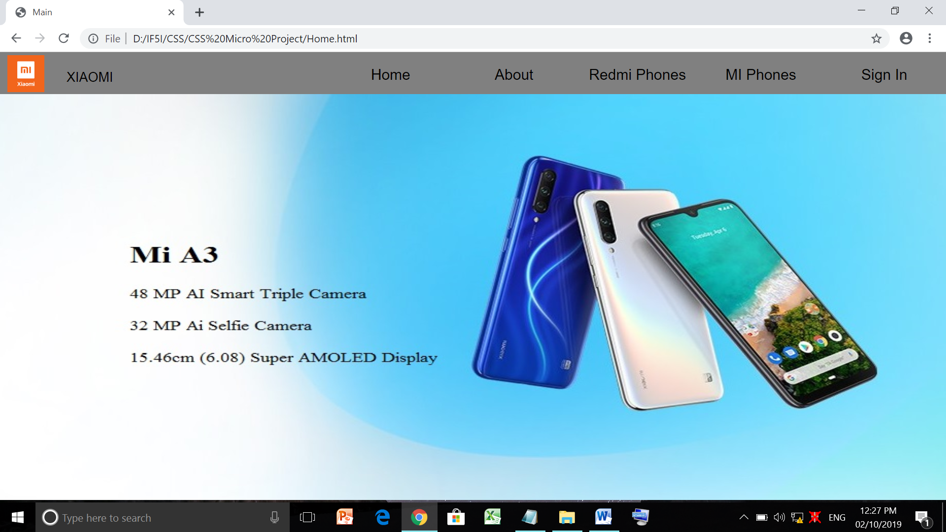

ABOUT

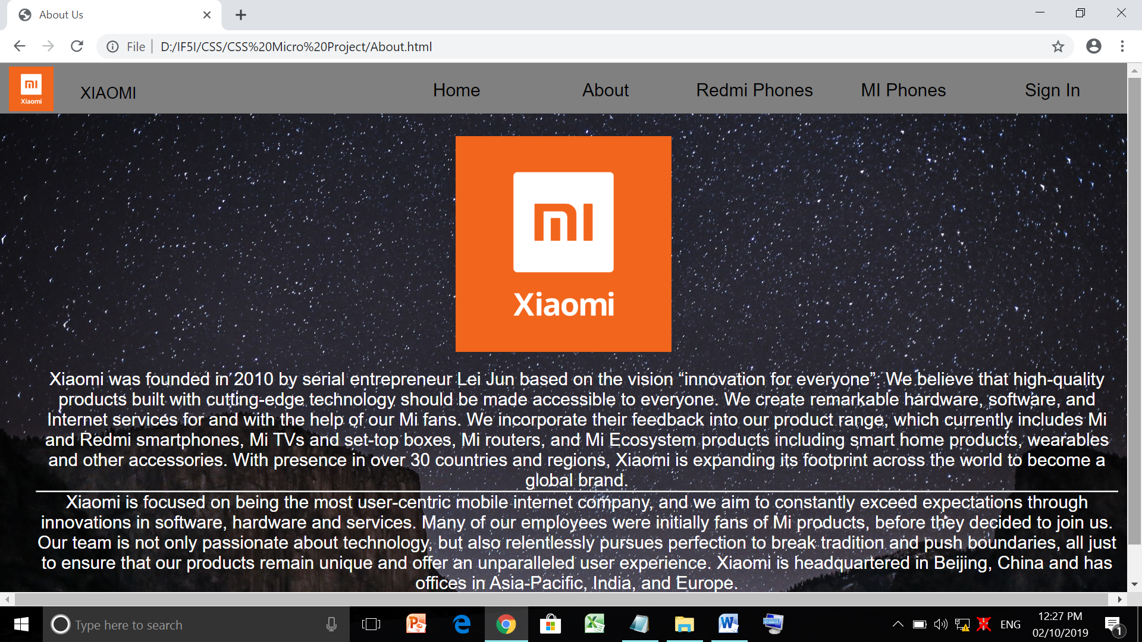

REDMI PHONES

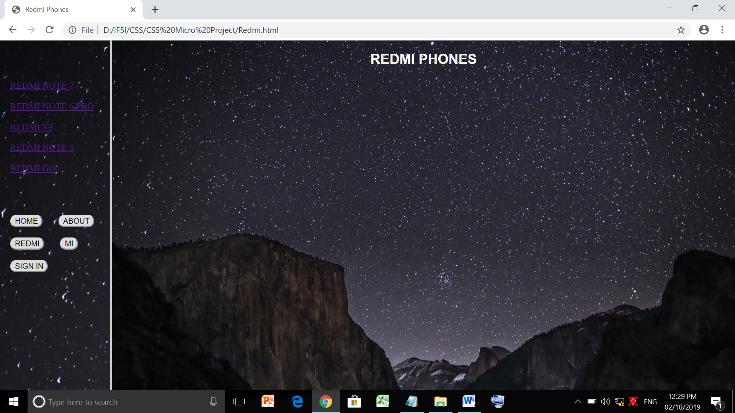

REDMI PHONE 1

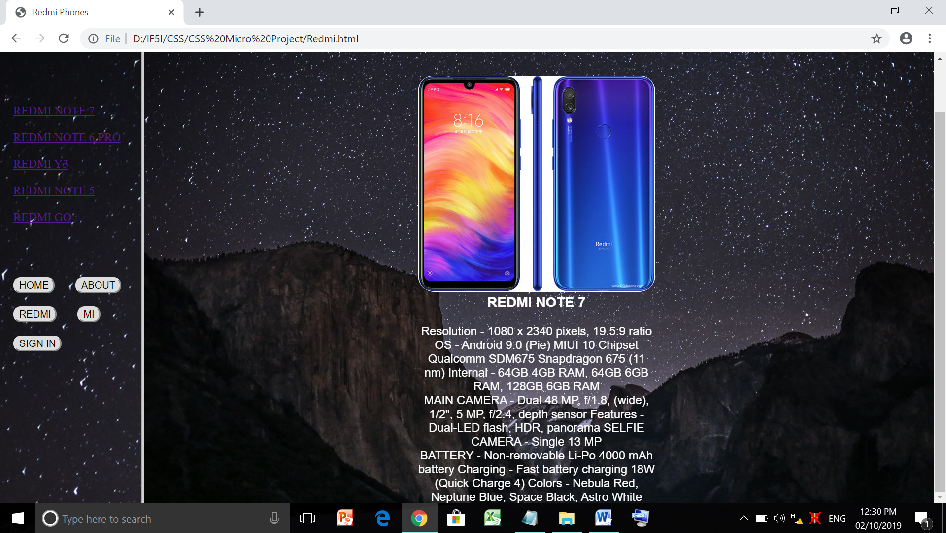

REDMI PHONE 2

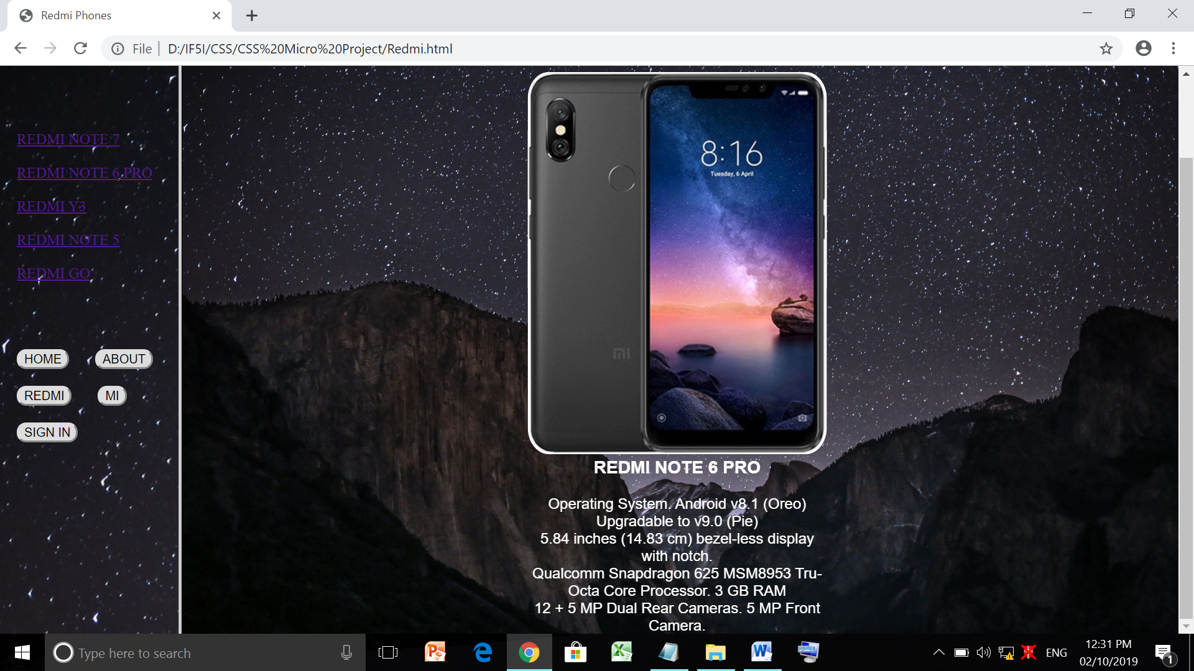

REDMI PHONE 3

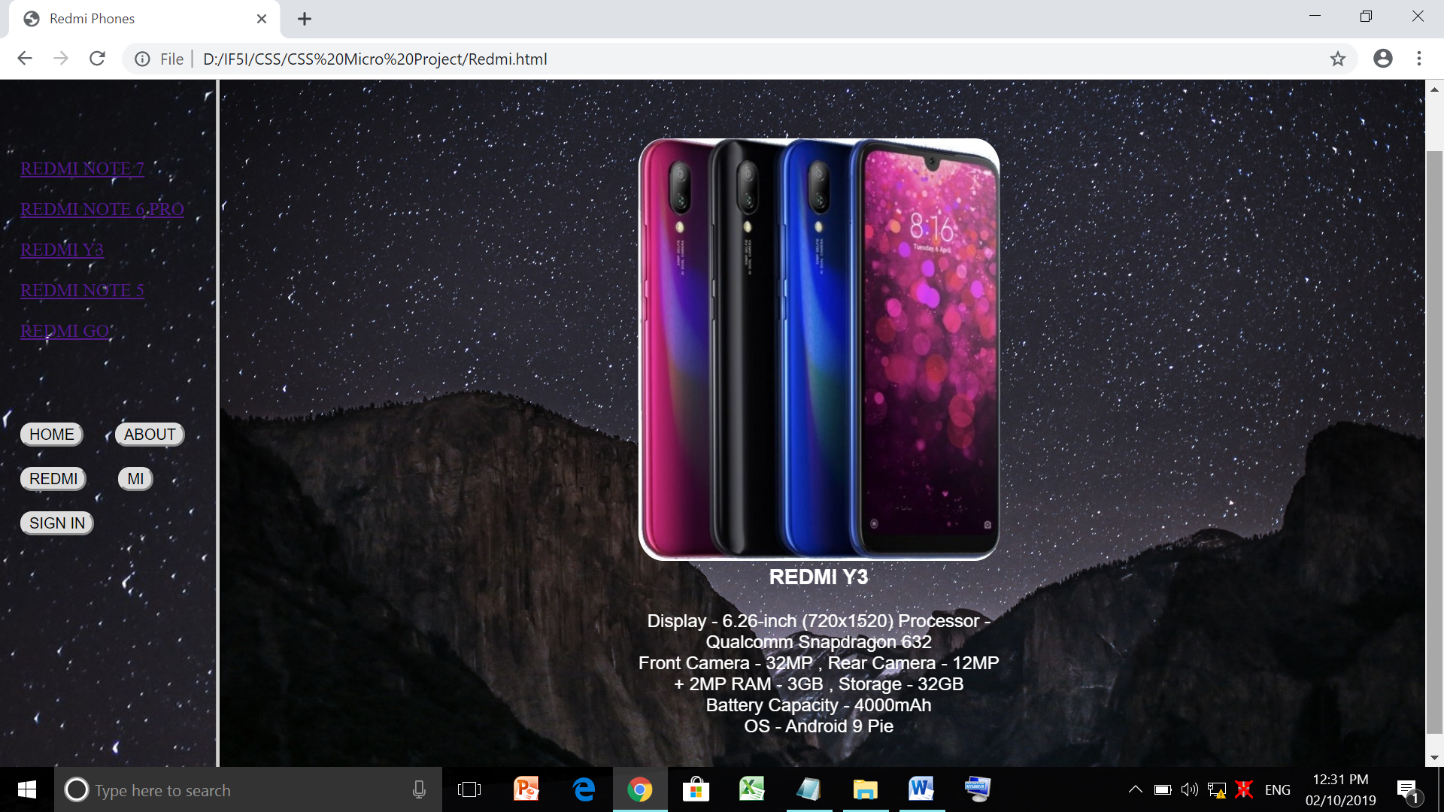

REDMI PHONE 4

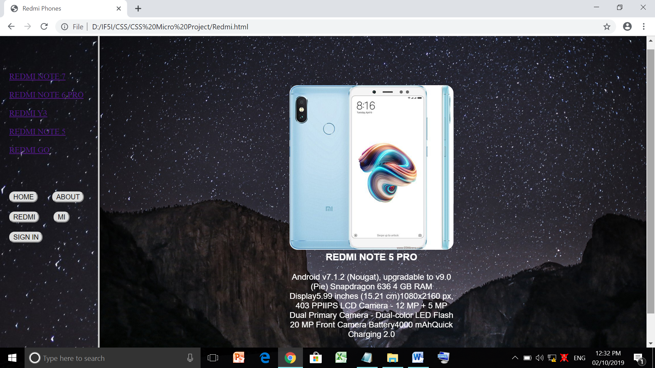

REDMI PHONE 5

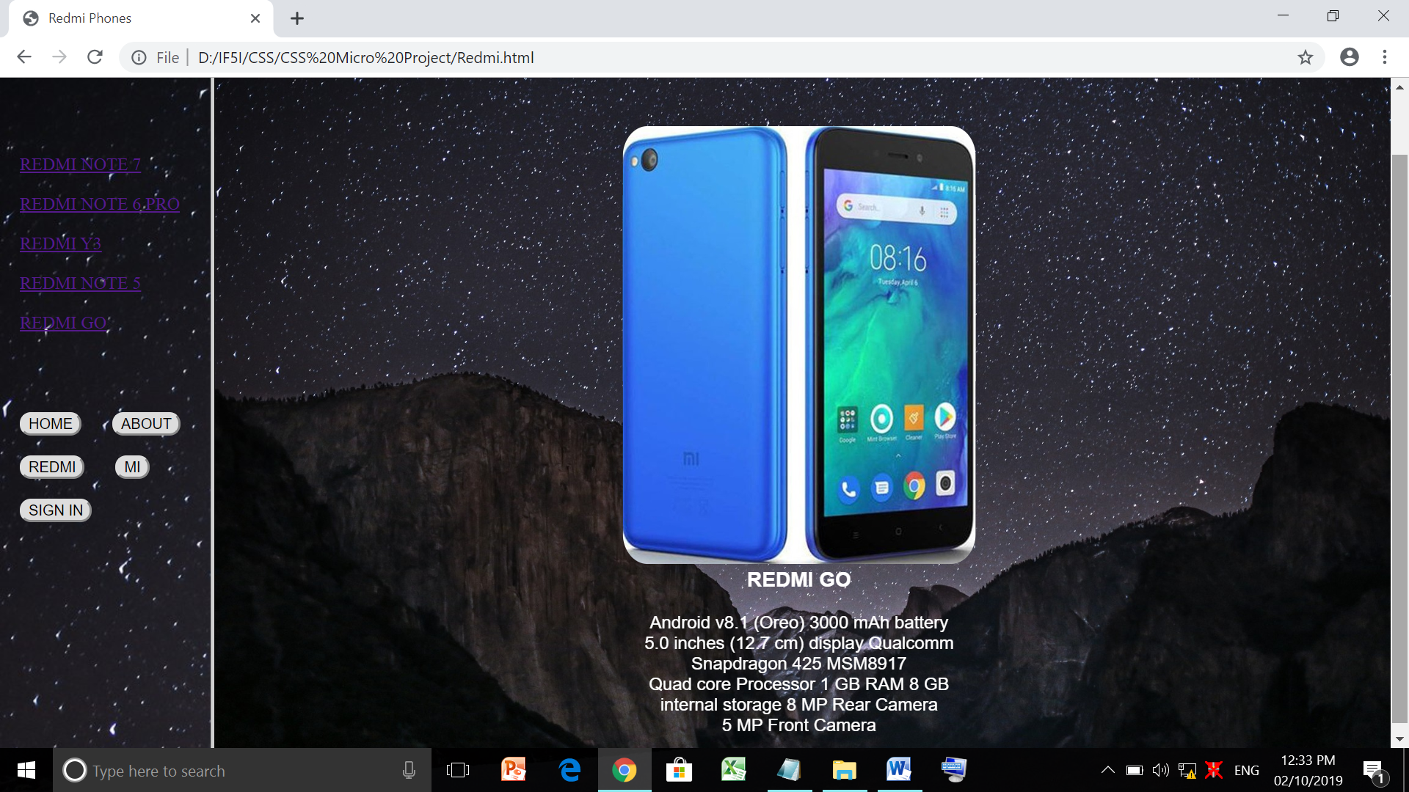

MI PHONES

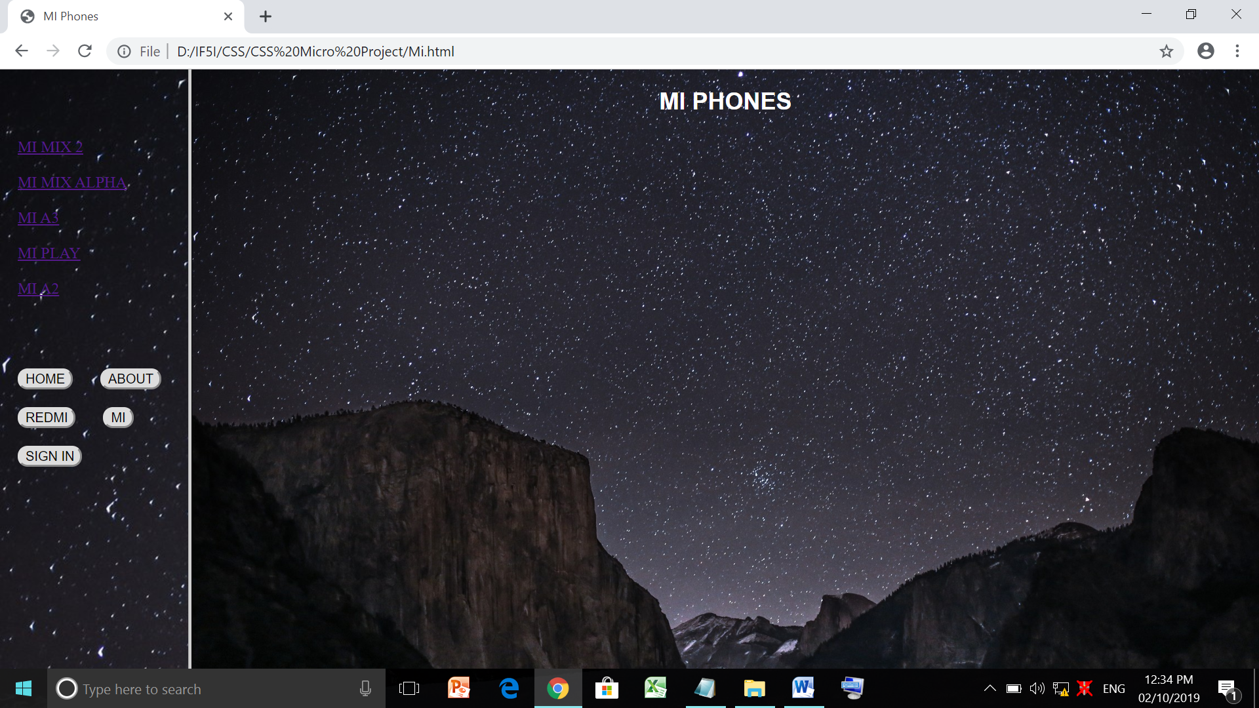

MI PHONE 1

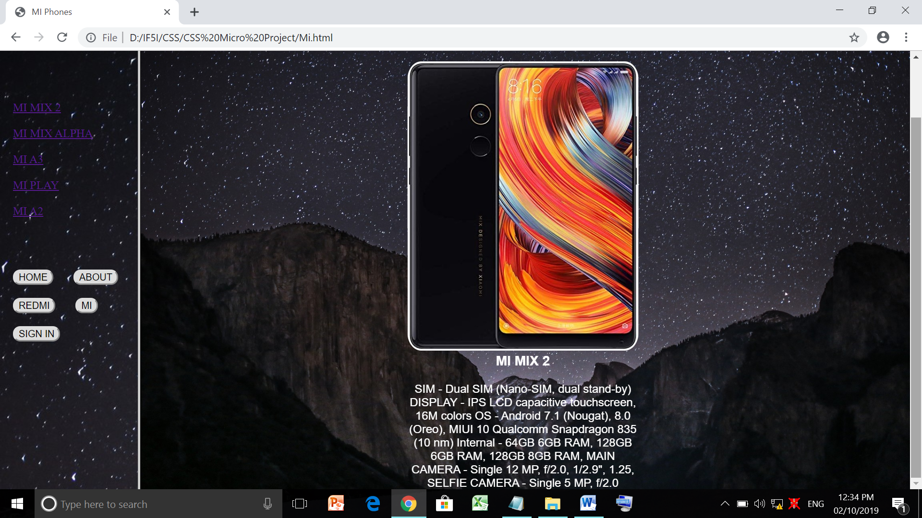

MI PHONE 2

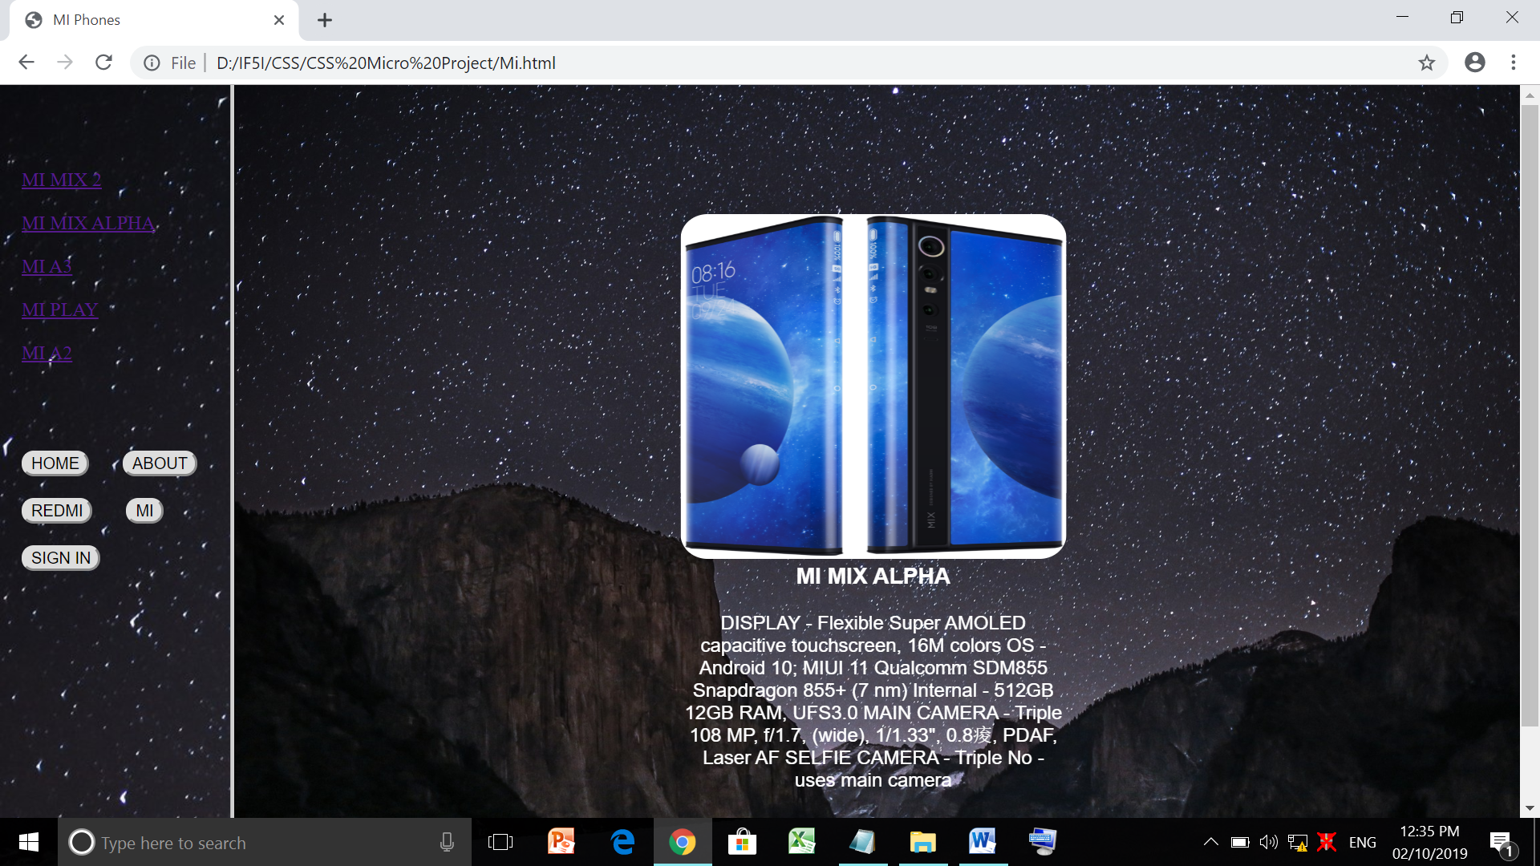

MI PHONE 3

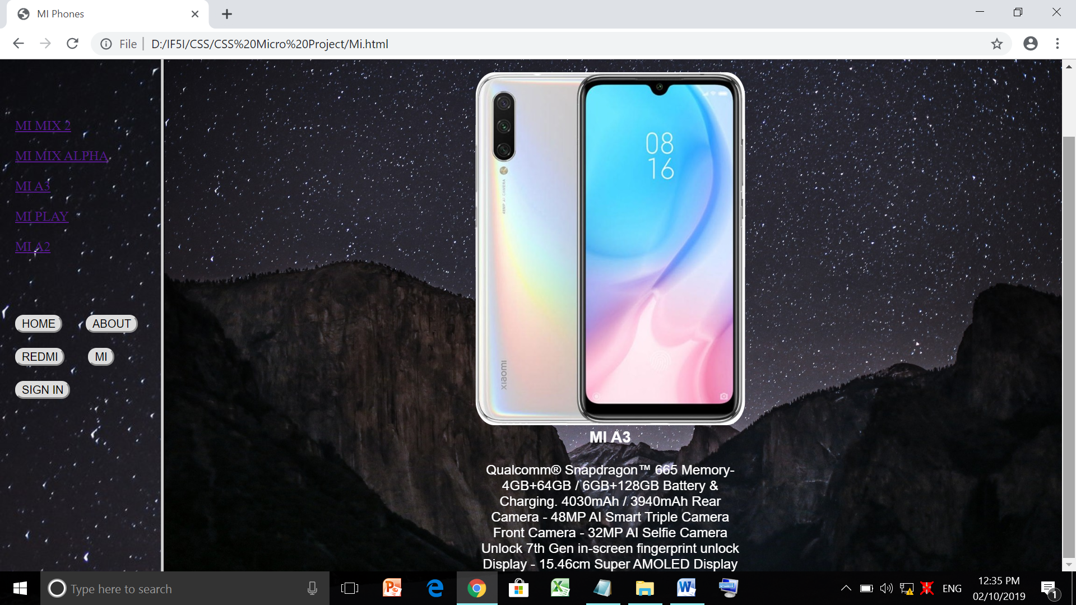

MI PHONE 4

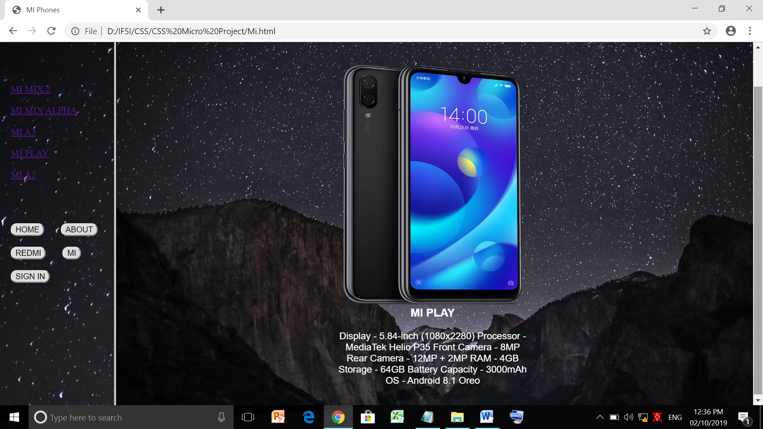

MI PHONE 5

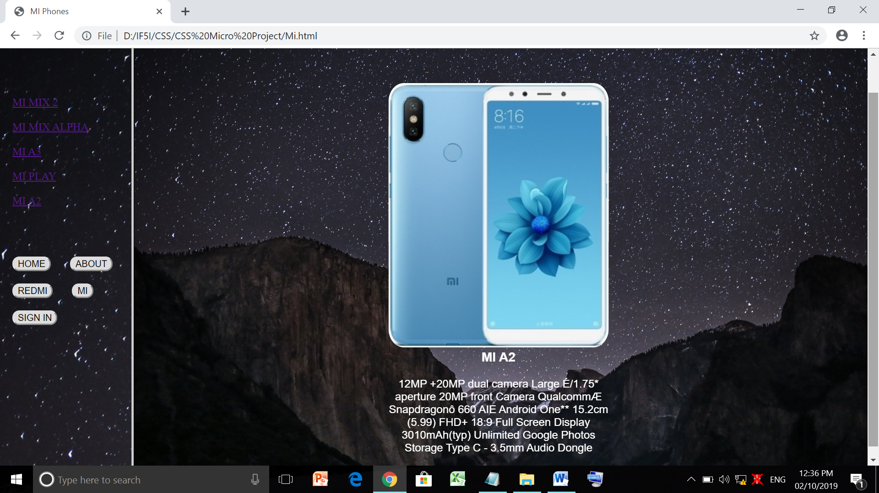

SIGN IN

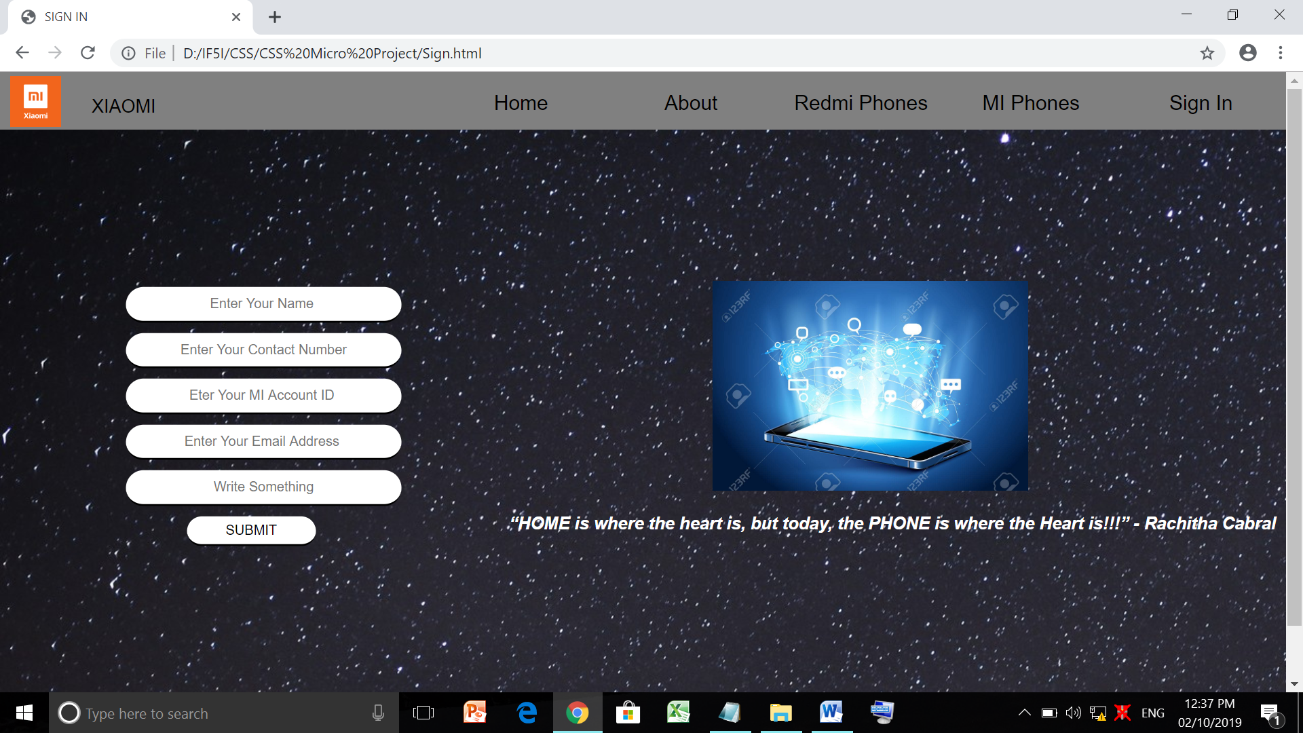

Regular Expression :

If nothing Entered Then:

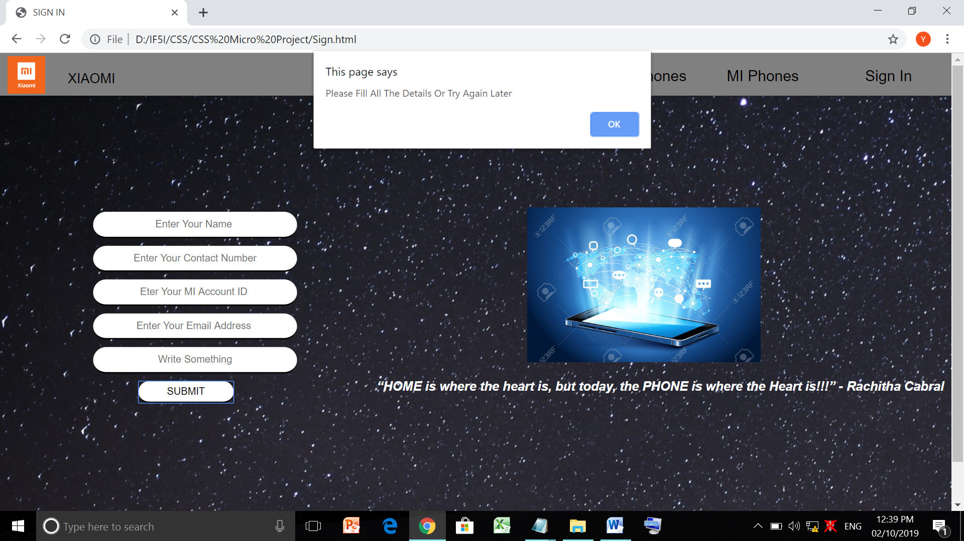

If Incorrect Name Entered Then:

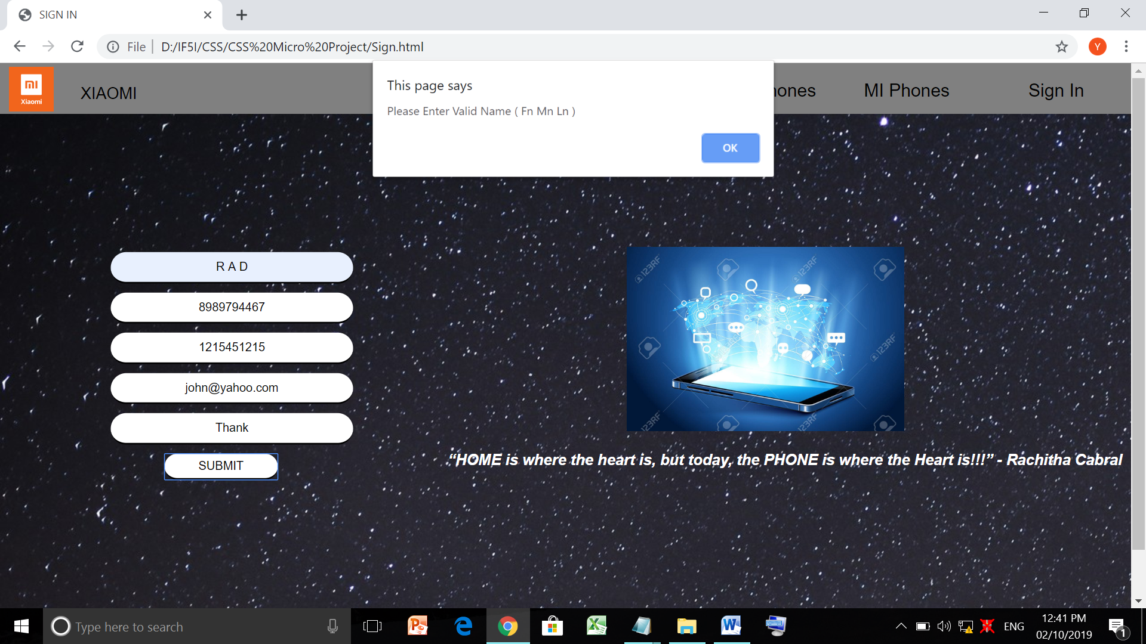

If Incorrect Contact Number Entered Then:

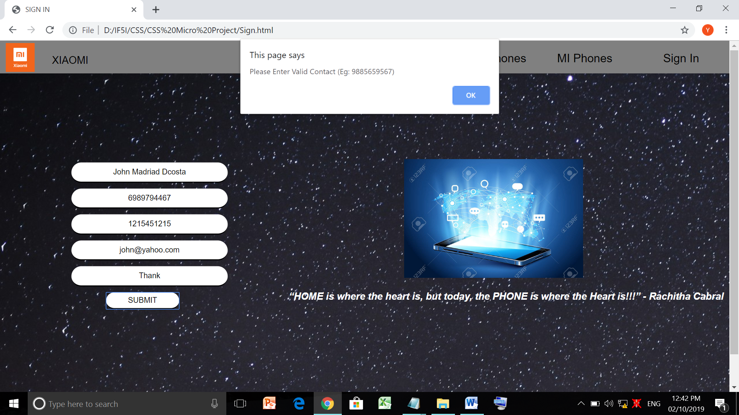

If Incorrect MI Account ID Entered Then:

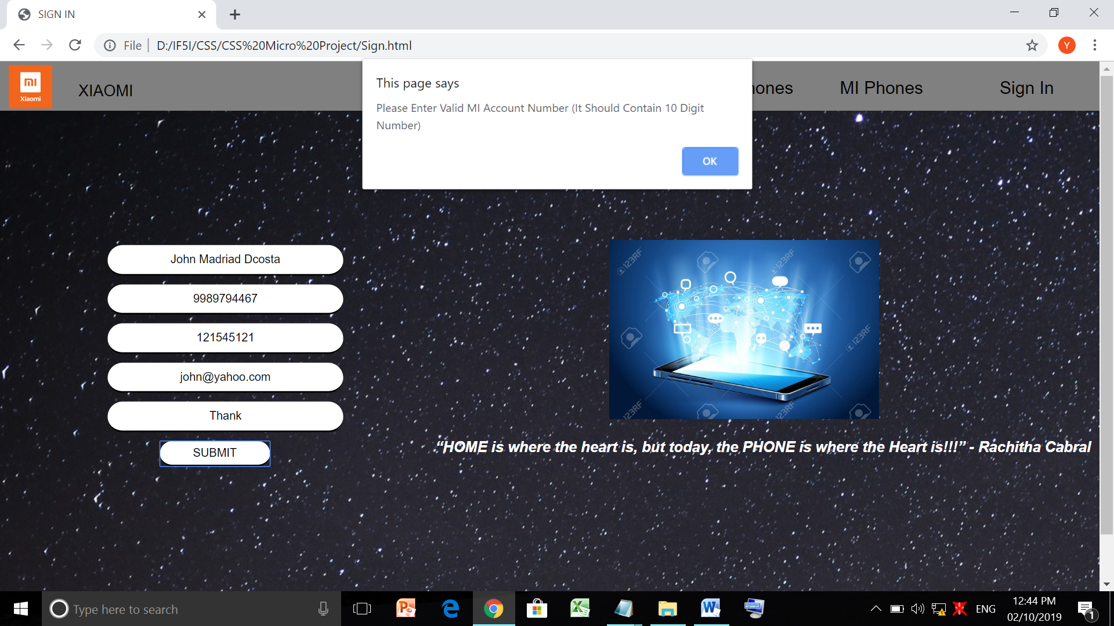

If Incorrect Email Entered Then:

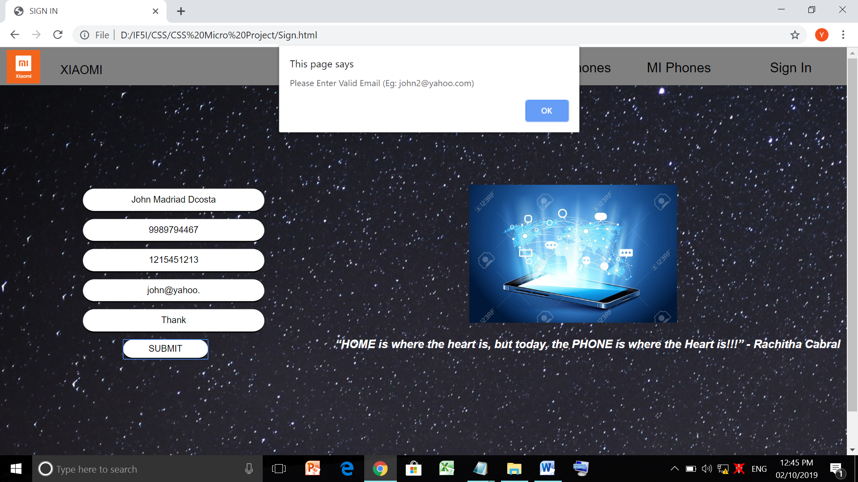

If Nothing Is Written In Feedback Then:

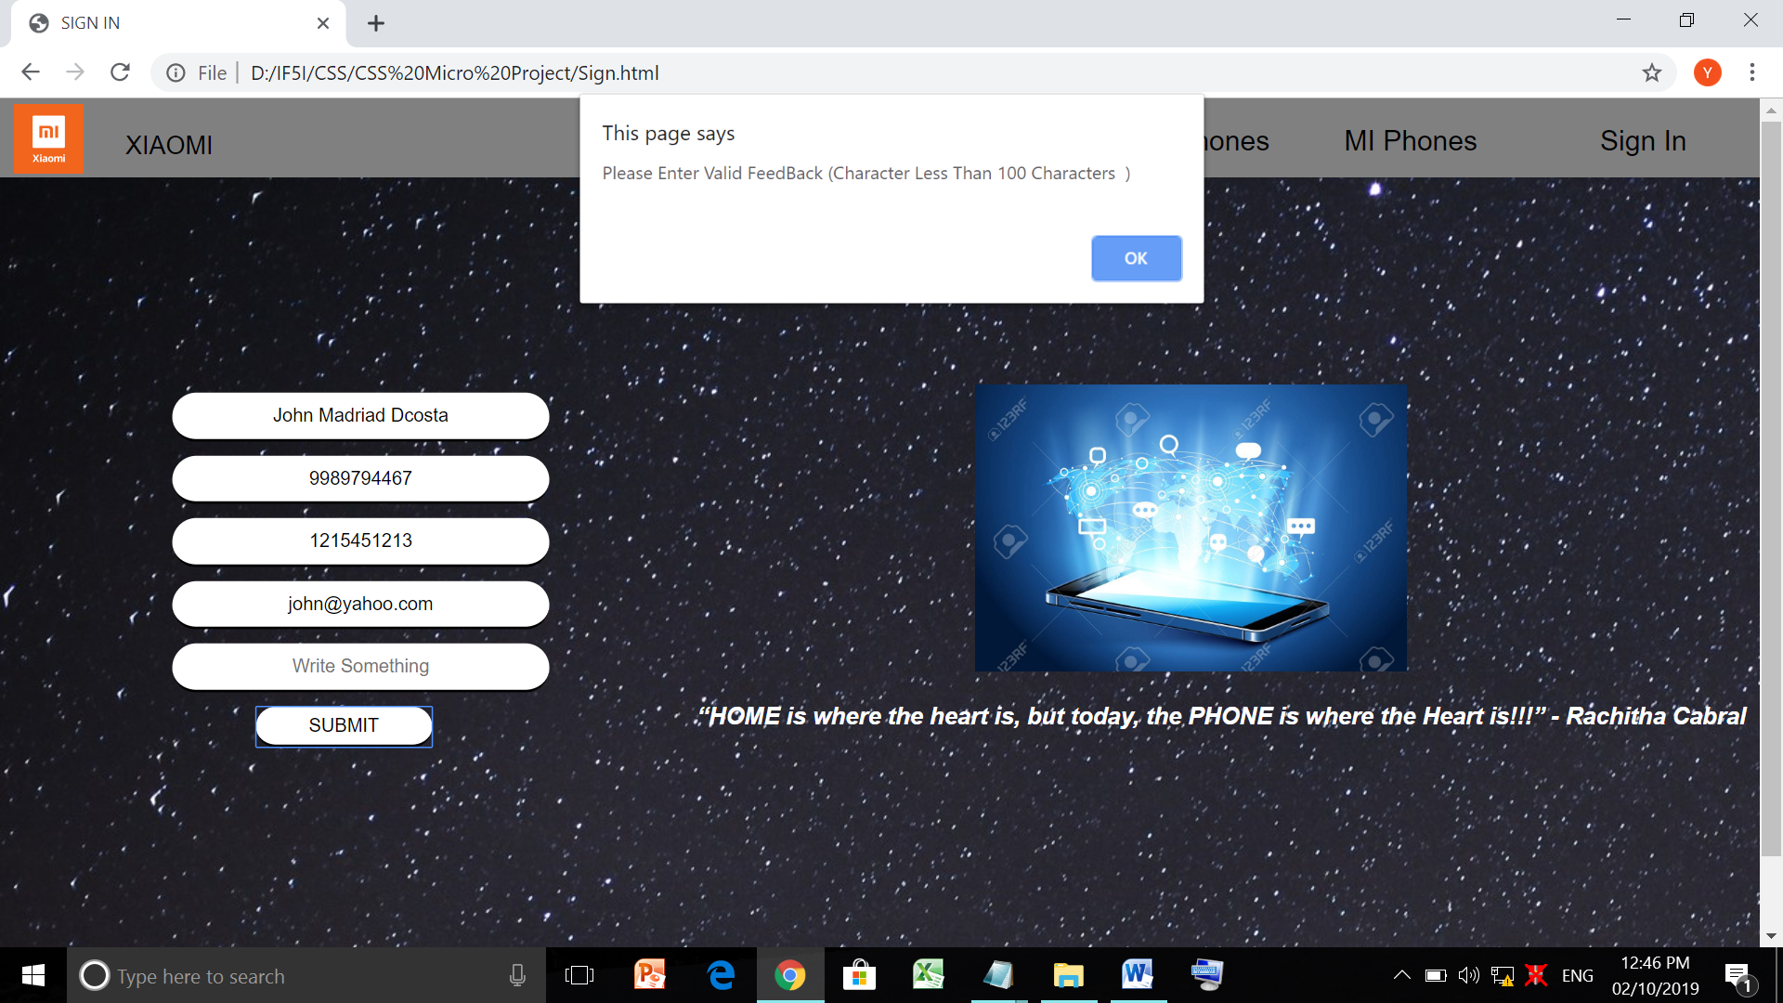

If All Details Are Fill Correctly Then:

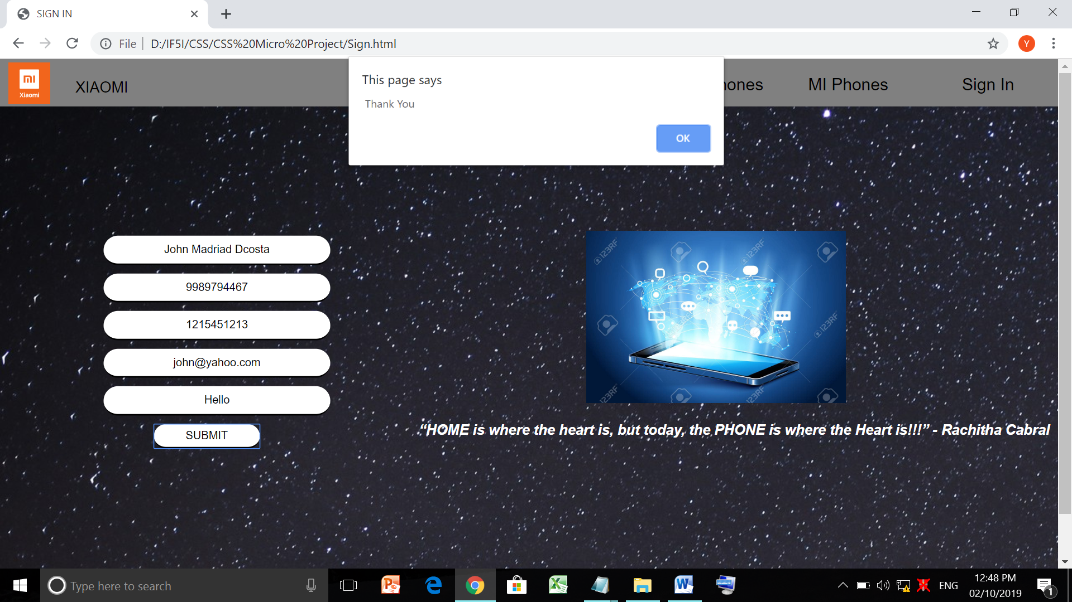

**Actual Resources used:-**

|  |  |  |  |  |
| --- | --- | --- | --- | --- |
| **S.No** | **Name Of Resources/Material** | **Specifications** | **Quantity** | **Remarks** |
| 1 | Computer System | Computer : i3  Ram : 4GB | 1 | ----------- |
| 2 | Operating System | Windows | 1 | ----------- |
| 3 | Development Software | Notepad  And Chrome | 1 | ----------- |

**Skill Developed/Learning outcome of this Micro-Project:-**

While Developing this Micro-project I get to learn various Client Side Scripting Languages In Details And Also Learn How To Implement Those Languages To Make A Professional Website.

**Application of this Micro-Project:-**

It Easy For Users To Search Different XIAOMI Phones Through This Website.